**THE WISE SLOTH STORY PLOT CALCULATOR DESIGN MANUAL**

**5/23/2021**



**Table of Contents**

**Introduction**

**Landing Page**

**Menus**

**Right-Clicking**

**New Story From Questions** **And The Variable Library**

**The Main Work Space**

**Sequences And The Bird’s Eye View**

**Plot Point Design**

**Target Audiences**

**Market Competitors**

**Supplemental Information**

**Introduction**

The Story Plot Calculator is a program that streamlines the process of writing stories by breaking them down into scenes and allowing you to insert premade and/or custom plot points which tell you what needs to happen in each scene. The plot points are based on psychology, established industry standards, and logical cause and effect relationships.

I'm putting this information on [Github](https://github.com/thewisesloth/Story-Plot-Calculator) because I want everyone to be able to have access to the highest quality story plotting/writing software possible, and I want this software to be able to be used for different purposes. You can use story plotting logic to write fiction for entertainment, psychological self-help planning, project management, artificial intelligence, and other applications I couldn't dream of. This software belongs in the public domain so it can have the greatest impact on society. That’s why I’ve chosen to release it under the [Creative Common Zero v1.0 Universal Public Domain Copyright license.](https://github.com/thewisesloth/Story-Plot-Calculator/blob/main/LICENSE)

I don't know how to code at all, and I don't understand Github's functions very well. So I'm totally unqualified to manage the pull requests and all that stuff. If you want to work on this project, I encourage you to download my documents and create your own Github project with it. If you put it on Github to share with the world, I will gladly consult with you and offer any help I can short of coding. Of course, if you want to make your own version and sell it for a profit, you have the legal right to do so without giving me any compensation. The only catch is, you can’t sue anyone else for copyright infringement if they make a similar program using the intellectual property that I’ve released to the public domain.

**Landing Page (AKA Home Page)**

When the user opens the program, the first thing they’ll see is the landing page. The landing page includes the title of the program on the top and buttons underneath it offering the following options:

* Start a new blank story
* Start a new story by answering questions
* Start a new story from a template
* Load a saved story
* Tutorial
* About

Below is an example of the landing page:

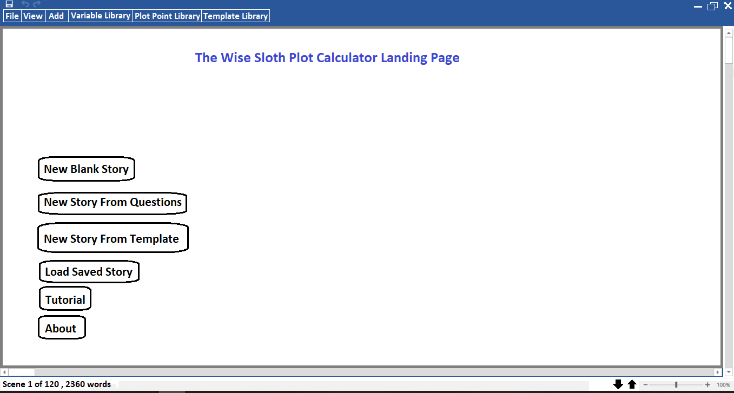

**Menus**

There are three permanent menus at the top of the screen. More will be added later probably.

* **File**

The “File” menu contains the following options:

* + New
  + Open
  + Save
  + Print
  + Export
  + Close
  + About
* **View**
  + Bird’s Eye View
  + Scene View
  + Show Narrative Work Space
  + Show Script Work Space
  + Show Sequence Maps
  + Show Plot Points
  + Show Plot Point Library
  + Show Plot Point Connections
  + Show Variable Library
  + Show Template Library
* **Add**
  + Add Blank Scene To Story
  + Add Scene From Template To Story
  + Add New Scene Template To Template Library
  + Add New Blank Sequence To Story
  + Add New Sequence From Template To Story
  + Add New Plot Point To Scene
  + Add New Plot Point To Library
  + Add New Note Card Between Scene In Story
  + ???
* Variable Library
  + *See the section of this document labeled “**New Story From Questions** **And The Variable Library”**
* Plot Point Library
  + % Markers
  + Themes
  + Sequence Themes
  + Motive Engine
  + Character Building
  + Desires
  + Inciting Incidents
  + Denouement
  + Sequences
  + Turning Points
  + Problem Chain
  + Mission
  + Internal Growth
  + Love Story
  + Conflict With The Antagonist
  + Types Of Conflict With The Antagonist
  + Director’s Notes
* Template Library
  + Complete Stories
  + Partially Complete Stories
  + Major Sequences
  + Minor Sequences
  + Scenes

**Right-Clicking**

When the user right clicks on a scene, a popup window will appear near their cursor displaying the following options:

* Insert New Blank Scene
* Insert New Scene From Templates
* Delete Scene

When the user right clicks a plot point in the main plot point column, a popup window will appear near their cursor displaying the following options:

* Remove Plot Point (This will only appear if there is already a plot point present.)
* Add New Plot Point

When the user right clicks a plot point in the plot point library, a popup window will appear near their cursor displaying the following options:

* Delete Plot Point
* Edit Plot Point

When the user right clicks the background in the plot point library, a popup window will appear near their cursor displaying the following options:

* Create New Plot Point

**New Story From Questions And The Variable Library**

Below is a list of questions the user will be asked if they choose to answer questions to build their story instead of starting from a blank sandbox. The answers to these questions will be added to the story’s variable library. Even if the user doesn’t answer these questions, they will still be able to access the variable library at any time and define them there. When information is entered into the variable library, it will propagate to the relevant plot points. For example, if the user defines the hero’s name as “John,” then the plot point, “State THE HERO’S Desire” will change to “State JOHN’S Desire.” If the user does not define these variables in the variable library, then the plot points they’re related to will remain in their original form.

* **Is this a novel or a screenplay?**

If the story is a novel, then the screenwriting column won’t appear in the work space. If the story is a screenplay, it will. This decision is not permanent and can be changed later from the “view” menu.

* **How many scenes are in the story?**

The user is shown the following options:

* 25 (short sitcom-length)
* 40 (long sitcom-length)
* 90 (short movie-length)
* 120 (long movie-length)
* Custom length

Whatever number the user enters, the program generates that number of scene slots on their workspace. In “custom mode,” each slot is populated with blank cards. If the user uses a premade template, then details will automatically populate into the cards.

* **How many major sequences are in the story?**

The program places a marker on the user’s workspace between the scene cards at the 12%, 33%, 50%, 77%, 99%, and 100% mark. All the scene cards between 99%-100% will be automatically nested under a major sequence labeled, “Denouement.”

If the user chooses 5 major sequences, then the program creates 5 major sequence slots/cards. Then the program divides the total number of scenes (excluding the scenes in the denouement) by 4. If the story has 100 scenes, and the user chooses 5 major sequences, then the first three Major sequences will have 20 cards nested under each of them. The 4th will have 19, and the 5th (denouement) will have 1.

* **How many minor sequences are in the story?**

The program divides the number of major sequences by the number of minor sequences and distributes the minor sequences across the major sequences evenly (excluding the Denouement).

If there are 5 major sequences, and the user chooses 20 minor sequences, then the first 4 sequences will have 4 minor sequence cards nested under them. By default, the denouement only has one minor sequence. If there are 100 scenes total, then each minor sequence will have 5 scene cards nested under it. By default, the denouement only has 1 scene card.

*After the workspace has been partitioned, regardless of whether the user is in sandbox mode, a template, or populating their story by answering questions, after this point, they will always be able to add and delete scene and sequence cards. The %markers will automatically change when the length of the story changes.

The user can drag and drop any scene or sequence card in any respective scene or sequence slot. The user can expand and contract the boundaries of sequences by clicking and dragging the card edge.

* **Define the characters.**
* **What is the total number of characters?**
  + **How many major characters are there?**
  + **How many minor characters are there?**
  + **How many character teams are there?**
    - **How many members are in each character team?**
  + **Define the character teams.**
    - **Who is the leader of each team?**
    - **Who are the other members of each team?**
* **How many locations are there?**
  + **Define the locations.**
* **Define as many of the following characters as you want in your story.**
* Protagonist
* Antagonist
* Ally
* Enemy
* Acquaintance
* Frenemy
* Lover
* Mentor
* Friend
* Best Friend
* Authority Figure
* Temptress
* Gatekeeper
* Minion
* Follower
* Confidante
* **Character Profiles**

Each character will have a page in the variable library that has all their character attributes. When these attributes are defined, they will propagate into the relevant plot points. For example, if the user types that the hero’s name is “John,” and John’s strength is “bulletproof skin” then the plot point titled, “THE HERO uses their strength,” will change to “JOHN uses BULLETPROOF SKIN.”

In the future, these attributes may get drop down boxes in addition to a text box, so the user can select from a list of choices for the character’s starting location, desire, strength, virtue, etc.

The profile page contains the following information:

* Name
* Picture
* Role
* Importance
* Starting location
* Home
* Desires
* Ultimate goal
* Character’s Final Fate
* Strengths
* Weaknesses
* Virtues
* Flaws (aka psychological dysfunction)
* Skills
* Morals
* Duties
* Relationships
* Signature personality traits
* Signature reactions
* Signature strategy for solving problems
* Known wisdom
* Known information
* Maturity / Enlightenment level / Completeness level / Self-Actualization level
* Expectations
* Hope status
* Fear status
* Satisfaction status
* Deprivation status
* Financial status
* Social Status
* **Usable Variables**
  + Physical resources
  + Information
  + Locations

**Example of a character profile page using graphic cards:**

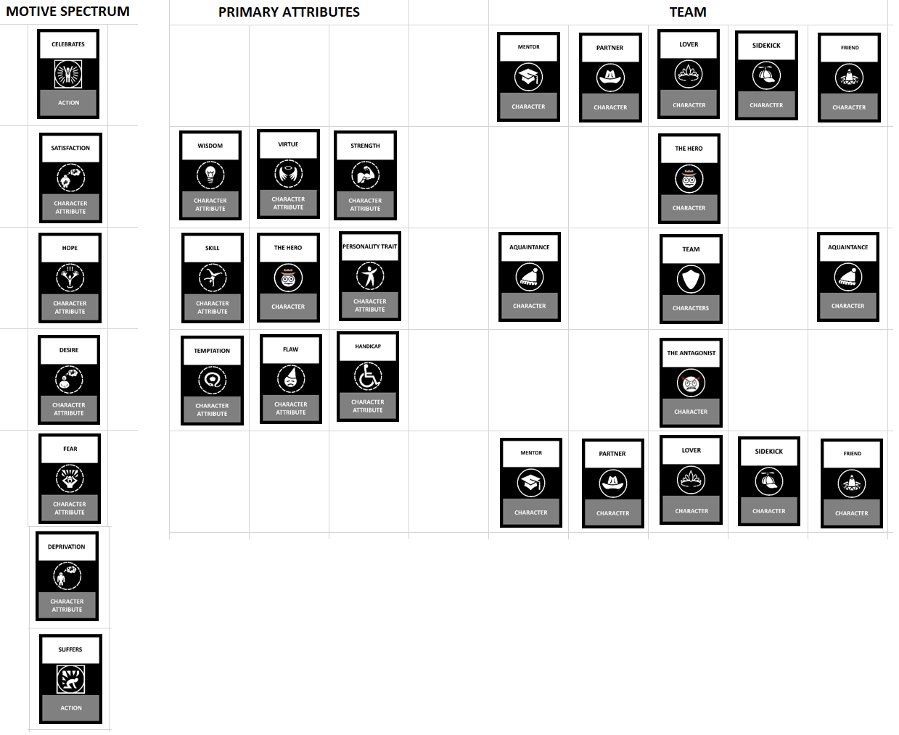

**The Main Work Space**

A blank project begins with a set of vertically stacked scene slots. When you click on a slot you get the option to delete, duplicate, fill manually, or fill with a template. You can also drag and drop the scenes before/after each other.

Below are 5 different ways the main work space could look.

[Here is a link to a Google Spreadsheet with the following 5 examples.](https://docs.google.com/spreadsheets/d/16n3T0OxF63RoelymaJh48hNHk1GVeRiOCOruCNAfKjo/edit#gid=1022408206https://docs.google.com/spreadsheets/d/16n3T0OxF63RoelymaJh48hNHk1GVeRiOCOruCNAfKjo/edit#gid=1022408206)

**Option 1:**

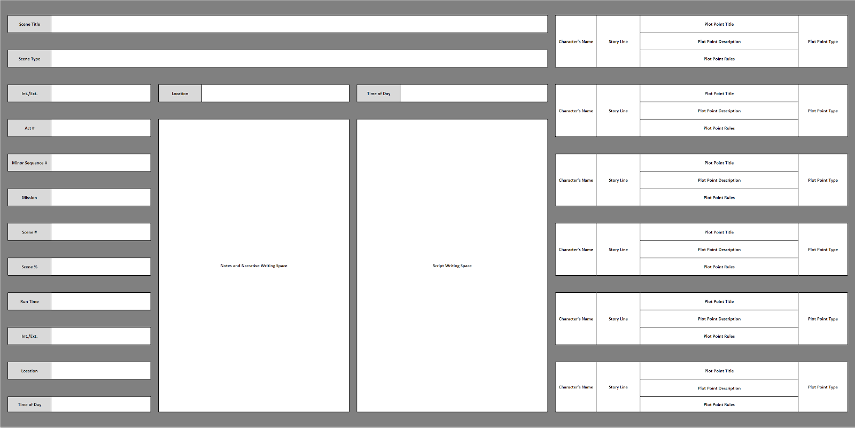

**Option 2:**

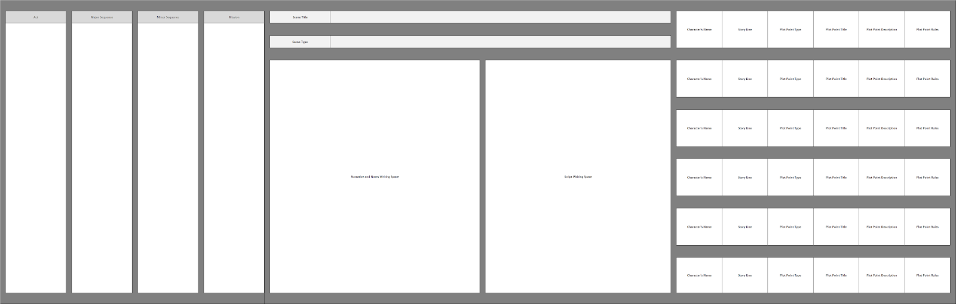

**Option 3:** 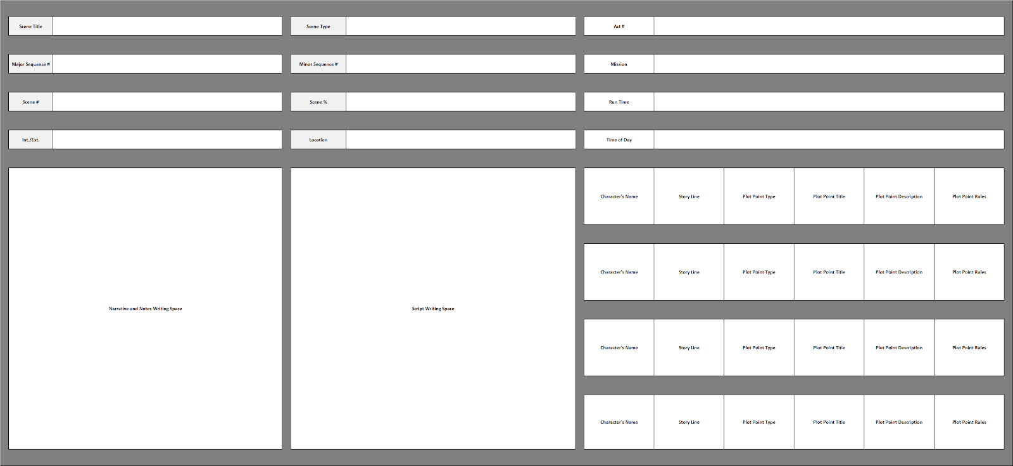

**Option 4:**

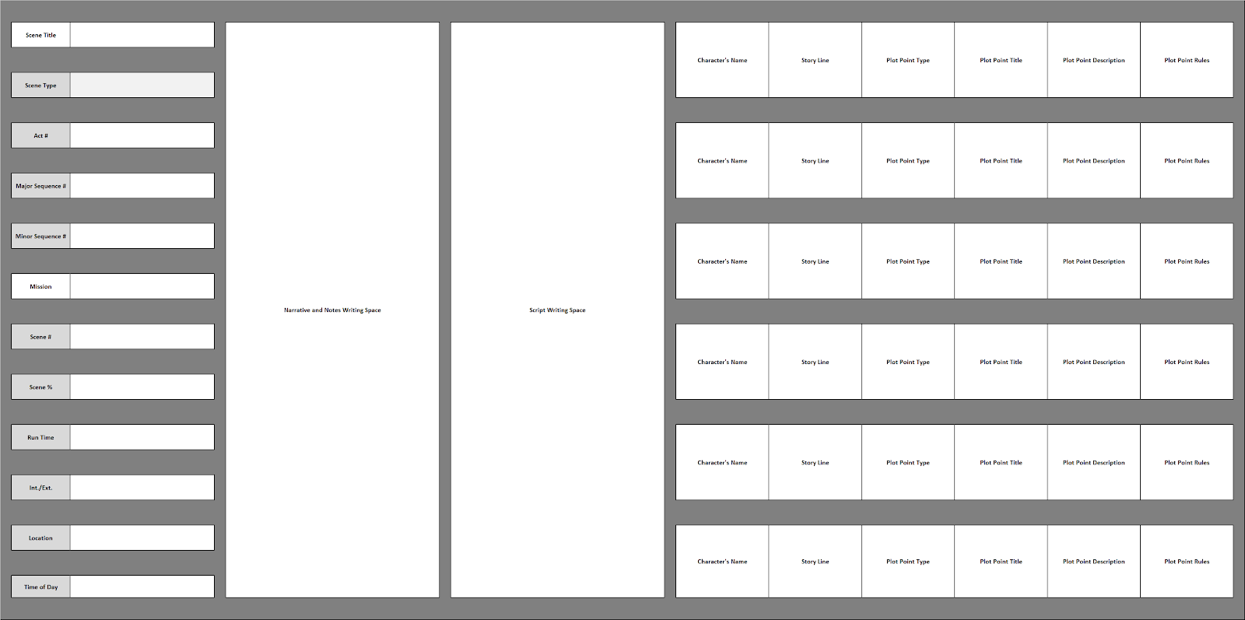

**Option 5:**

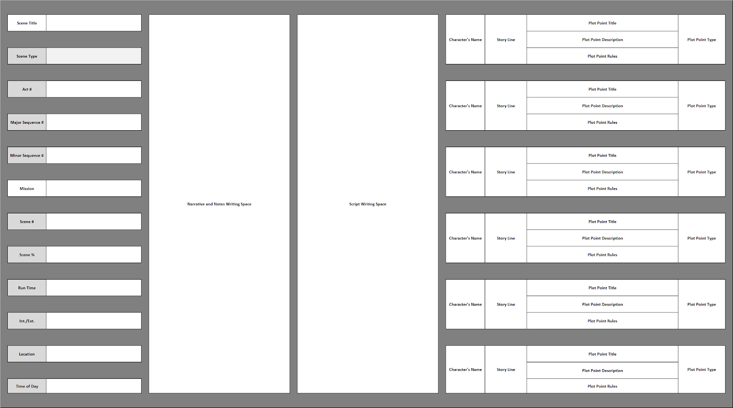

**Description Of Fields In the Main Work Space**

**Scene #**

The sequential number of the scene in the movie. This is calculated automatically. If you move a scene from slot #4 to slot #11, the scene number will change from 4 to 11. If you delete the scene, all the other scenes after it automatically update their scene number.

**Scene %**

This number is automatically generated also. It shows the percent of the film that is complete at any given scene. For example, the first scene will always be 1%, the middle scene will be 50%, and the final scene will be 100%.

**Run Time**

This number represents the length of the scene in relation to the movie’s run time. For example, if the first scene of a movie is one minute and thirty seconds long, then the run time is “0:01-1:30.” The run time box has two clock fields positioned side by side. The one on the left is labeled, “Start Time.” The one on the right is labeled “end Time.”

**Major Sequence**

This is the number of the major sequence. It’s number can be automatically generated.

**Minor Sequence**

This is the number of the major sequence. It’s number can be automatically generated.

*Note: Major and minor sequence boxes may need two text fields- one for the title and one for a description.

**Mood**

When you click this field you get a pop-up box that lets you select from a set of moods to describe the scene.

**Tension Level**

This is the level of tension you want the audience to feel. I can refine this later. For now it can be “high, normal, and low.”

**Scene Title**

The Title of the scene. This is a text box that you can type in.

**Int./Ext.**

This has three options that you can select from a drop down box: “Interior,” “Exterior,” or “Interior and Exterior.” This information is used to help the production crew plan, and it is exported automatically to the script view.

**Location**

The name of the location the scene takes place in. You can either click on it and enter your own text, or you can click another part of the box and it will open a popup box that will allow you to select a location from your location database. If you type in a location that isn’t in the database, it will be automatically added to the location database.

**Plot Points**

The column on the right is for a list of plot points used in the scene. *Note: Perhaps we should make the “Plot Points” column its own major column separate (and located beside) the scene column.

When you click an empty plot point box, you get a pop up box that lets you select from a list of pre-made plot points. If a plot point needs to connect logically to another plotpoint later in the story, then an arrow will appear to the right of the plot point. When you click the arrow, it will create a movable line that you can drag to another scene and connect it to a relevant plot point there.

**Main Screen Without Expositional Fields**

You could potentially eliminate all the exposition fields and just have the narrative space, the plot points, and/or the file browser that lets you drag and drop plot points into your story.

Below are a few examples of what that could look like. In this image, the user has gone into the “view” menu and chosen to show the plot point library.

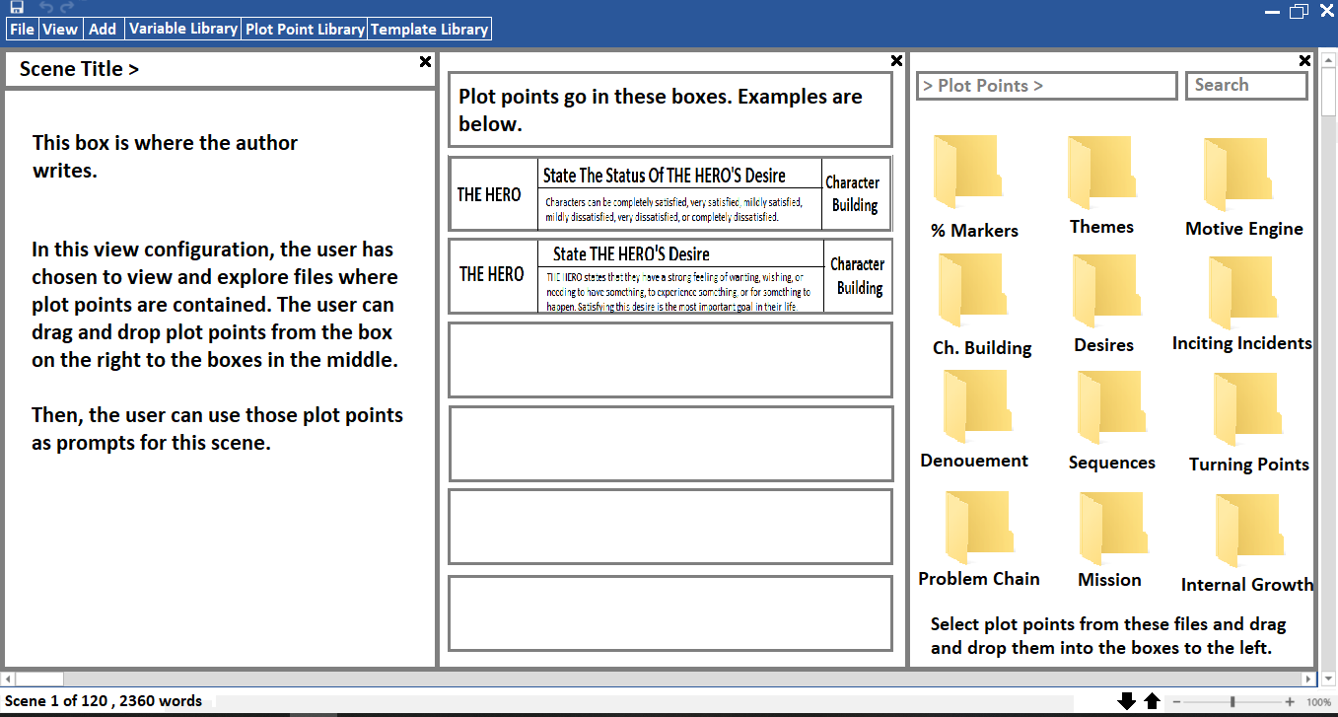

In this image, the user has gone into the “view” menu and chosen to hide the plot point library.

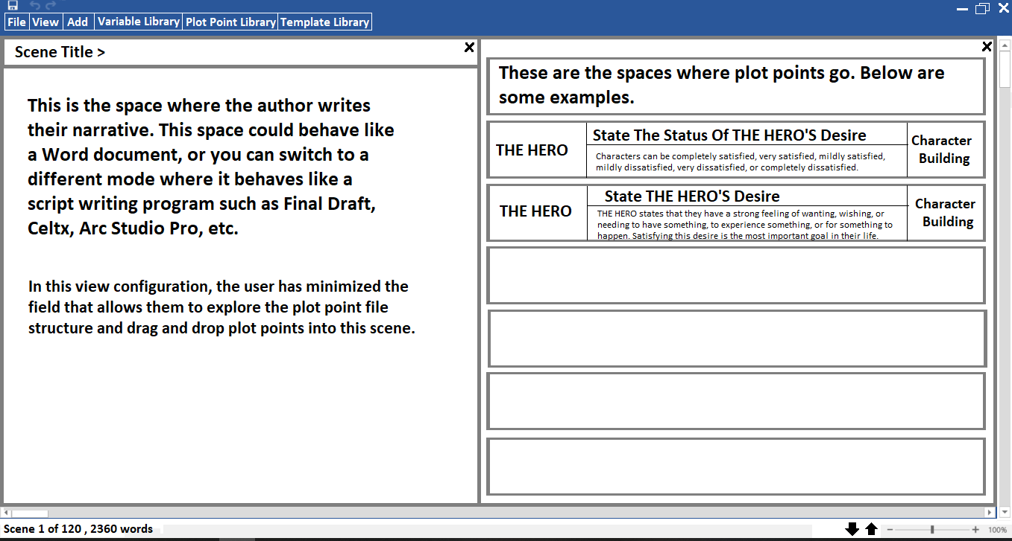

**Sequences and the bird’s eye view**

Sequential scenes can be grouped into small and large interconnected, logically flowing sequences of events such as a car chase, the final fight, or a mission phase. In order to see these, the user needs to be able to mark them and zoom out to see a bird’s eye view of their story. In the bird’s eye view, the program feels more like you’re using Microsoft Excel. When you’re zoomed into the scene view, the program feels like you’re using Microsoft Word.

* **Minor Sequences**

The user can highlight a group of scenes and make them a minor sequence. When that happens, the scenes are surrounded by a larger card in the background. The user can choose to have the scenes displayed vertically or horizontally within the minor sequence card.

The sequence cards will also be dynamic widgets with all the same features as the scene cards. The biggest difference is that the minor sequence cards display the scene cards it's made of, and major sequence cards display both its minor sequence cards and their scene cards.

Example of vertically displayed minor sequence:

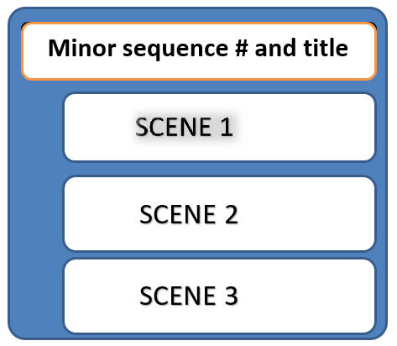

* **Major sequences**

Minor sequences can be nested into major sequences the same way scenes are nested into minor sequences.

Example of major sequence:

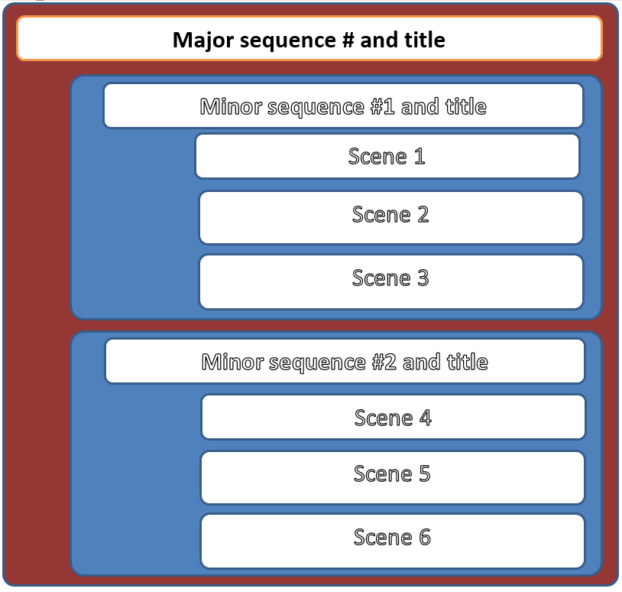

Example of sequences when combined:

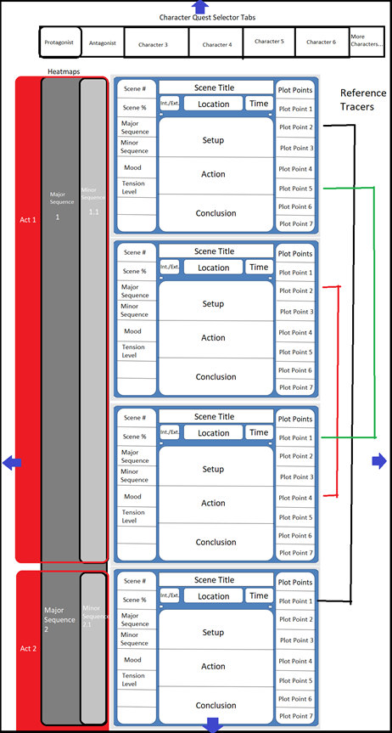

**Note cards**

You can add note cards in-between scenes. I may add ideas for more dynamic note cards later, but for now they can just be text boxes.

Below is an example of works space with a note card place between scenes in the bird’s eye view.

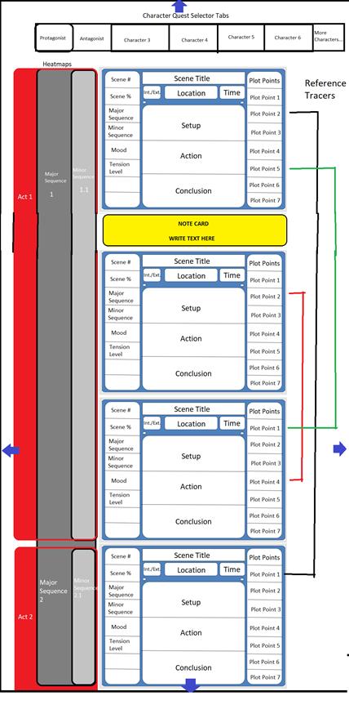

**Alternate way to express Major Sequence breaks**

The heat maps are still on the left side of the screen, but when a sequence begins, it branches into the main workspace and provides space where you can write information.

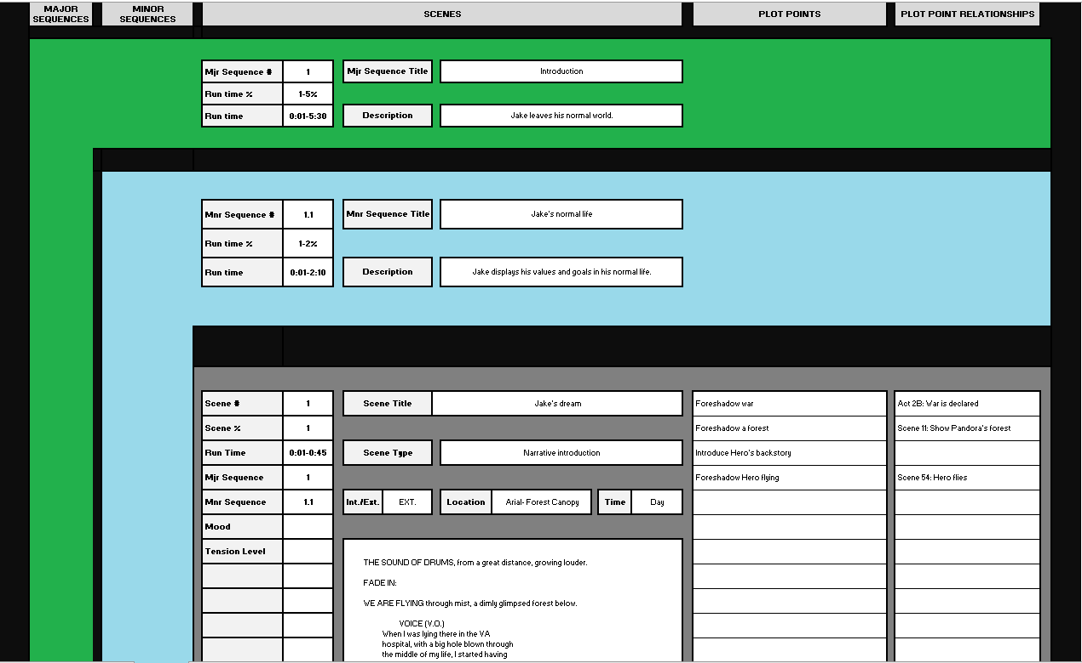

**Sidebar Columns**

Below are three examples of the works space in the bird’s eye view, where the user has chosen to show or hide different columns:

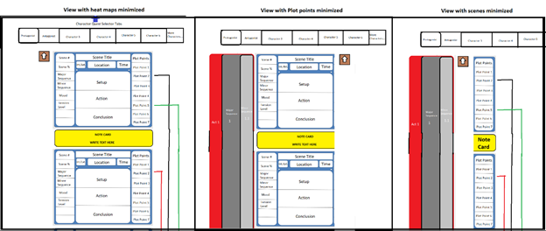

These are the columns you can use:

* **Sequence Map**
* **Plot Points**
* **Plot Point Tracers**
* **Narrative work space**

**Plot Point Design**

As of today, I’ve compiled 241 plot points the user can choose to add to their story. I will be creating more in the future. You can download what I have in my [Github repository](https://github.com/thewisesloth/Story-Plot-Calculator/tree/main).

Plot Points are displayed in a narrow rectangular box that is subdivided into the following fields:

* **Character Name**

Since every character follows the same basic steps to complete their journey, any plot point can belong to any character. To distinguish which character the plot point belongs to, their name is displayed in the box to the far left. When you left click on the “character name” field, a popup box will be displayed next to the cursor showing a list of all characters. When you select a character, their name appears in the character name box. The character’s name will also propogate into the title field and the description field. So if the title is, “State THE HERO’S” desire, and you change name field on the left to THE ANTAGONIST, the title will change to “State THE ANTAGONIST’S Desire.”

* **Title**

This field displays the name of the plot point, which is essentially a summary of the description.

* **Description**

This field offers addition information elaborating on the plot point.

* **Plot Point Type/Category**

This field tells the user what type of plot point they are looking at.

Below is an example of a plot point:

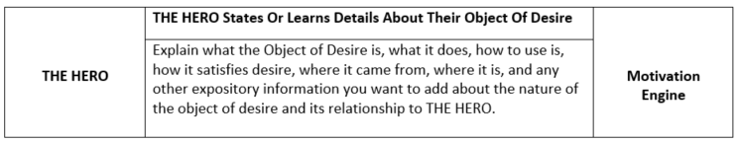

**Target Audiences**

* **VIP target audience**

Hollywood screenwriters, producers, directors, and agents who have the ability and motive to use this program to write major Hollywood movies and TV shows

* **Largest target audience**

People who want to write stories but don’t know anything about story writing and have no idea what to do. This program will walk them through the steps and teach them how to write coherent stories. This audience includes writing teachers, writing students, literature students, amateur writers, etc.

* **Secondary target audience**

People who have made a minor commitment to writing and want a reliable tool to craft moderately advanced stories while they practice and learn how to plot more advanced stories. This includes writing majors in university, film students, and advanced hobbyists.

* **Lowest target audience**

Go-with-the-flow writers who don’t like structure and just like to wing it.

**Market Competitors**

* [Arc Studiopro](https://www.arcstudiopro.com/)

**Pros:** Story-organization software with drag and drop plot points, the ability to tag assets, create connections between them, and it has predictive text writing. You can tag text in your script and add labels and connections that way.

**Cons:** The plot planning and organization functions lack structure. They’re useful, but they don’t tell you what to write.

* [Contour](https://marinersoftware.com/product/contour/)

**Pros:** Primarily a story organizing software. It asks you questions to help you outline your story and guides you through a major sequence template. It also includes templates for several successful movies.

**Cons:** The templates and questions provided are weak and vague.

* [Causality](https://www.hollywoodcamerawork.com/causality.html)

**Pros:** It’s a powerful program with a lot of functions (maybe too many). It’s best asset is being able to create and program connections between assets (beats, scenes, plot points).

**Cons:** Excessive menus and disjointed work spaces make it confusing and gives it a steep learning curve. It offers minimal templates to tell you how to structure a story.

* [Scrivener](https://www.literatureandlatte.com/scrivener/overview)

**Pros:** A solid word processor with collaboration functions. It has lots of functions for organizing your story with notes, outline views, fullscreen writing view, the ability to look at multiple scenes at once, a corkboard view.

**Cons:** The functions and views are clunky to navigate through, and they don’t tell you what to do.

* [Final Draft](https://www.finaldraft.com/)

**Pros:** A solid word processor with a clean interface that’s great for writing and collaborating.

**Cons:**  It doesn’t tell you what to write and has minimal organization functions.

* [Studiobinder](https://www.studiobinder.com/)

**Pros:** It’s a powerful program with a lot of functions related to managing an entire movie production.

**Cons:** Most of the programs functions revolve around planning a movie production. As sleek as the storyboard function looks, it lacks the ability to quickly and easily organize plot structure and doesn’t tell you what to write. Its grid format also limits the amount of information you can display about scenes.

* [Celtx](https://www.celtx.com/index.html)

**Pros:** A movie production software like Studiobinder. Also includes multiple story structure organization tools.

**Cons:** The scriptwriting aspect is only one part of a larger, more confusing whole. The organization tools it does have are segregated into different view modes.

**References to competitors’ features**

* **Consider adding a feature like Arc Studiopro’s “Arc Mode.”**

See minute 1:10-1:30 on [this Youtube video](https://www.youtube.com/watch?v=RBtJI5yjlR8&ab_channel=ArcStudioPro). Also see 1:27-2:30 i[n this video](https://www.youtube.com/watch?v=UbTFseqyZAI&ab_channel=ArcStudioPro).

* **We don’t want to use a grid layout like in Studiobinder**

A cascading column-based workspace is preferable to a grid-spaced workspace like [Studiobinder’s storyboard mode](https://www.youtube.com/watch?v=qMXdkcqj-as&ab_channel=StudioBinder) because in a column-based workspace there is more room on the screen to show additional information about each scene. When your scenes are packed into a grid, you don’t have room to display supplemental information.

* **We don’t want studio project management functions**

This isn’t total project management software for director/screenwriters. This is software that organizes stories. We don’t need functions to help schedule shoot times, assign jobs, plan activities, create call sheets, or anything not related to organizing story structure. Even functions like being able to add video, audio, and graphic storyboards are probably too much.

* **Consider adding the ability for users to add a pop-up sticky note to any variable (scene, sequence, character)**

You tag a scene (or other variable) and it creates a little button on the corner. When you click the button a note space pops up where you can write and view notes. This is a useful tool for making reminders to oneself, and it gives other people the ability to leave notes on other people’s scripts.

* **Consider designing plot points to move and interact with related plot points similar to** [Causality’s “Causality Tags”](https://www.youtube.com/watch?v=I3A0ozmWk0E&ab_channel=HollywoodCameraWork) which allow you to create [dependencies that can generate error messages](https://www.youtube.com/watch?v=Xh57Z1UOryw&ab_channel=HollywoodCameraWork).
* **Minimize advanced text editing features**

The main purpose of this program is not to make pretty documents. It’s to make useful documents. Adding advanced text editing features spends time we could be using to make features that help people organize stories. Plus, advanced text features require buttons to access them that would make the program more cluttered and distract from the purpose of the program.

* **Minimize hiding features behind new windows, modes, and menus.**

Causality is a powerful writing tool, but its not intuitive or easy to approach. You have to learn where everything is and how it works and cycle through different views. We want to keep tools on the screen and easy to access without having to jump through hoops to get what you want.

* **Considering being able to add and label new columns like in** [**Causality’s “Lanes.”**](https://youtu.be/SxzXcKWgzWg)

Stories have multiple story lines occurring concurrently. To be able to keep them separate, we may need to be able to add new “lanes.”

* **Users need to be able to select multiple objects and group them**

If you select a group of scenes, you can tag them as being a minor sequence, major sequence, act, internal quest, external quest, unique character’s quest, mission, mission phase, theme, and possibly more.

* **Every plot point is “owned” by a character.**

Each plot point applies to a specific character. So users need to be able to tag a plot point to show who it applies to.

**\*End of Instructions\***

**The rest of the information is this paper isn’t instructions on how the plot program operates per se. This information explains the types of templates the user will be able to load, and if gives a general overview of story structure to help explain how all these different types of plot points and sequences connect to make a story.**

**Supplemental Information**

**Sequences**

Sequences are collections of scenes. Below is a list of types of sequences. The specific scenes that would load when you select a sequence have not been compiled yet.

**List of Major Sequences**

* Inciting Sequence
* Post-Inciting Sequence
* Debate/Decide/Plan/Prepare
* Fall in Love
* Missions
* Final Mission
* Denouement

**List of Minor Sequences**

* Introduce the Hero
* Introduce the Antagonist
* Get an Opportunity
* Get a Problem
* Mission Briefing
* Find a Solution to the Problem
* Escalate Conflict
* Refusal of the Call
* Plan/Prepare
* Debate/Decide
* Get/Accept Mission
* Attempt Mission
* Major-Sequence Final Showdown
* Reaction to Outcome of Previous Outcome
* Fall in Love
* Dark Night of the Soul
* Fix Their Flaw
* Final Fight (Finale)
* Find a Character
* Get a Character
* Recruit Team
* Denouement

**Scenes**

**List of Scenes**

* First Scene
* Final Scene
* First Fight
* Meet Lover
* Make a Mission Plan
* Accept a Mission
* Complete a Mission
* Fail a Mission
* Accomplish a Goal
* Fail a Goal
* Get a Reward
* Get a False Reward
* Final Fight (Finale)
* Attempt to Solve the Problem
* State the Goal
* Regroup
* Recover
* Get Reward
* Debate
* Refusal of the Call
* Decide to Accept Mission
* Plan a Mission
* Prepare
* Big Speech
* Introduce a Major Character
* Introduce the Hero
* Introduce the Antagonist
* One-Off Conflict
* Denouement
* Get the Incentive
* Use the Incentive
* Sunset

**Missions**

Goals vs Mission

Mission is how to obtain a goal

**List of Missions**

* Find a Solution to their Ultimate Problem
* Answer a question
* Final Mission
* Intro Mission that is a metaphor for the rest of the story
* Intro Mission that directly yields the character’s next mission
* One-Off Intro Mission that Encapsulates the Hero
* Escape a Location
* Find a character
* Fight a character
* Help a character
* Kill a character
* Capture a character
* Acquire a resource
* Learn important info
* Learn a skill
* Prevent an event
* Recruit an ally
* Find a clue
* Find a Location
* Travel to a Location
* Escape a Location
* Defeat a Team
* Final Fight
* Win first place in a tournament
* Win a competition
* Pass a test
* Infiltrate a character’s Castle
* Storm a character’s Castle
* Defend their Castle

**Plot Points**

Unsorted

* Character gets reward
* Character gets punishment

Character Building

* Introduce Character’s Name
* Introduce location
* Introduce character’s home
* Introduce personal inventory
* Introduce primary desire
* Introduce flawed desire
* Introduce starting goal
* Introduce ultimate goal
* Introduce external strength
* Introduce external weakness
* Introduce internal virtue
* Introduce good habit (what the hero does to act out the virtue)
* Introduce internal flaw
* Introduce bad habit (what the character does to act out their flaw)
* Introduce Character’s Skill
* Introduce Character’s Beliefs (a specific internal rule the character obeys)
* Introduce Character’s Values (a general internal rule the character obeys)
* Introduce Character’s job
* Introduce Character’s job status
* Introduce Character’s Duties
* Introduce Character’s Routines
* Introduce Character’s Relationships (with teams and other characters)

For Directors

* Opening credits
* First image
* Final Image
* Introduce mood
* Introduce story tone
* Introduce story rules
* Foreshadowing

Desires

* *Introduce Character’s desire
* Character’s satisfies desire
* Character’s desire is satisfied
* Character’s desire is unsatisfied
* Character’s desires to satisfy his desire
* Character’s desires to have the experience he expects will happen if he satisfies his desire
* Introduce Character’s  expected outcome of using the object of his desire
* Character’s enjoys satisfaction
* Character’s suffers deprivation
* Character’s desires satisfaction
* Character’s fears suffering
* Character’s fears the outcome of depriving his desire
* Character’s starting satisfaction status
* Character’s final satisfaction status
* Deprivation status

Possession

* Character has asset
* Character doesn’t have asset

Actions

* Character performs action
* Character gets asset
* Character loses asset

Knowledge

* Character knows info
* Character doesn’t know info
* Character learns info
* Character gets info

Goals

* Introduce Character’s Ultimate Goal
* Introduce Character’s Immediate Goal
* Introduce Protagonist’s Ultimate Goal
* Introduce Antagonist’s Immediate Goal
* Introduce Status of Character’s Current Satisfaction Level
* Character’s celebrates success
* Character’s suffers consequence of failure
* Character’s gets a setback

Planning

* Debate possible plans
* Introduce the plan
* Make a plan = Debate and Introduce the plan
* Enact plan
* Plan gets dashed
* Debate possible “Plan B’s”
* Introduce “Plan B”

 Missions

* Character finds mission opportunity
* Character gets mission opportunity
* Character debates accepting mission
* Character refuses to accept mission
* Character accepts mission
* Character learns a mission condition
* Character makes a mission plan
* Character prepares for mission
* Character fails to satisfy mission condition
* Character fails mission
* Character gets a mission setback
* Character gets new mission condition
* Character satisfies a mission condition
* Character suffers consequence of failing mission
* Character regroups and recovers after failing mission
* Character completes mission
* Character celebrates completing mission
* Character is rewarded for completing mission
* Character hero begins first mission
* Character begins second mission
* Character begins third mission
* Character begins final mission
* Introduce Character’s Current Mission
* Introduce Risk of Accepting Mission
* Introduce Cost of Accepting Mission
* Introduce Benefit of Accepting Mission
* Introduce Character’s Expected Outcome of Completing Immediate Mission
* Introduce Character’s Expected Outcome of Completing Next Mission
* Introduce Character’s Expected Outcome of Completing Immediate Task
* Introduce Character’s Expected Outcome of Completing Next Task
* Introduce Character’s Expected Outcome of Completing Final Mission
* Introduce Character’s Expected Outcome of Completing Final Task
* Character prepares for mission
* Character prepares for final mission
* Introduce the stakes of the mission
* Introduce the risks of the mission
* Introduce the conditions of the mission
* Introduce the objectives of the mission
* Introduce the goal of the mission
* Introduce the expected outcome of the mission
* Introduce the expected reward for accomplishing the mission
* Introduce the expected cost/punishment for failing the mission
* Character Neutralizes the Antagonist

Milestones

* Teaser
* Status quo
* Cross the point of no return
* Introduce Protagonist
* Predicament
* Inciting event
* Lock in
* Turning point (general)
* Turning point 1
* Midpoint
* Cliff hanger
* Act 1 debate
* Backstory
* 1st attempt to solve problem
* Living with the inciting incident
* Mind of the opponent
* Introduce the stakes
* Theme Introduced
* Break from storyline
* B-story
* Character tells the hero what their problem really is, but the Hero can’t see it
* Lock in
* Act 1 turning point
* Return with Act 1
* Introduce motivation
* Introduce stakes
* Opponent
* Hero’s philosophy
* Antagonist’s philosophy
* Protagonist’s ultimate goal
* Protagonist’s starting goal
* Antagonist’s ultimate goal
* Antagonist’s starting goal
* Protagonist meets a mentor
* Protagonist prepares for Act 2
* Enact 2nd attempt to directly solve problem
* Setback
* Raise the stakes
* Raise the risk
* Raise the number of conditions to success
* Truth revealed
* Victory
* False victory
* Reversal
* Start Act 2b
* Bad guys close in
* Protagonist’s low point
* Dark night of the soul
* An impact character making the Hero try again
* New decision
* New effort
* New plan
* Act 2 turning point
* Preparing for climax
* Lead up
* Obligatory scene
* Climax
* Resolution
* Denouement
* New equilibrium
* Epilogue
* Roll credits

**The 5 Stages of a Story**

Every story is a logical cause/effect sequence of events about a character attempting to satisfy his defining desire. Audiences watch stories to explore and satisfy their own desires vicariously through the character. Since the audience’s experience is a projection of their own psychology, a good story will mimic the steps of human motivation and cause/effect.

**Introduction (AKA Inciting Sequence, AKA Motivation Engine) Stage**

Every story begins with a minor and major sequence that introduces the Hero, reveals the hero’s desire, the status of his satisfaction (whether his desire is satisfied, unsatisfied, or he’s dissatisfied). Then the story will give him options for how to get the object that will satisfy his desire, use the object, and experience the satisfaction he craved. The introduction always ends with the Hero either refusing to accept a quest and attempting to return to his normal life, or the Hero accepts his quest and crosses a point of no return.

The Introduction sequence can end no earlier than the 5% mark, and it must end by the 24% mark. It is recommended to end it at the 12% mark.

**Post Intro/Pre Mission Stage**

If the Hero refuses his quest, his desire will remain unsatisfied, and he will suffer negative consequences, which will make him return to the path. After the hero accepts his quest, he will need to articulate the nature of the problem, its stakes, and the solution to the problem. He will need to make a mission plan to solve the problem, and he will need to train, prepare, gather, resources, allies, and information in order to articulate his problem and make a mission plan. At some point, he will debate the risk, rewards, and consequences of continuing and decide to commit to his journey and embark onwards.

This stage can be as short as one major sequence, or it can be subdivided into multiple major sequences. For example:

MS 1: Introduction Sequence

MS 2: State and Solve the Problem Sequence

MS3: Plan/Prepare for Mission Sequence

MS4: Debate/Decide/Embark Sequence

The Post-Intro Stage can begin no earlier than the 12% mark, and it must end by the 49% mark.

**Main Mission/s Stage**

A mission is a series of tasks the Hero must attempt and complete in order to yield an expected outcome. In other words, the Hero must perform a series of actions on a series of objects. Each time he completes an objective, it will cause an effect on another object.

Missions can have multiple objectives that are conditions for completion. Each series of tasks required to complete an objective will have its own minor or major sequence.

The Hero can begin his journey on a mission, which means the first major sequence will be the Introduction Sequence *and* either a standalone mission or the first phase of the main mission.

**Final Objective/Mission Stage**

After completing all the conditional objectives, eventually the Hero will attempt their final objective. This time, the Hero will confront the Antagonist or the source of their problem directly. In the final scene of this sequence, the Hero will neutralize/defeat the Antagonistic force or be neutralized/defeated by it.

The final objective stage can not end before the 95% mark or after the 99% mark.

**Denouement**

After the Hero defeats the Antagonist or otherwise neutralizes their problem, he will receive the outcome of his action. This is always directly related to his desire and the object of his desire. He either does or doesn’t get the object of his desire. Whatever he gets either does or doesn’t satisfy his desire. The most basic expression of this sequence is either three beats or three scenes long and looks like this:

1. The Hero gets the object of his desire.
2. The Hero uses the object of his desire.
3. The Hero experiences the state he desires.

This is the sunset sequence. It shows the Hero walking off into the sunset. It gives a glimpse of his future. It answers all the unanswered questions.

The denouement ends at the 100% mark.

**Internal Quests**

Major characters can have external and internal quests. It is recommended for at least the Hero and the Antagonist to have an internal quest. The external quest is the series of steps the Hero physically does to get the external object of his desire. The internal quest is the steps the Hero takes to identify, understand, and neutralize his internal character flaw or psychological wound.

The events of the internal quest can happen in dedicated scenes and sequences, or then can happen during beats in the Hero’s external quest. The simplest expression of the Internal quest uses these steps:

* The Hero uses his flaw.
* The Hero suffers negative consequences for using his flaw.
* The Hero learns the identity of his flaw.
* A Character tells the Hero his flaw.
* The Hero decides not to change.
* The Hero has an “aha” moment and understands his flaw.
* The Hero fixes his flaw.
* The Hero becomes his true self.

**Love Quests**

Love quests can be main missions or side missions. They follow the same deceptively simple steps as real life relationships:

* Meeting a lover
* Talking to a lover
* Touch a lover
* Get to know a lover
* Kissing a lover
* Having sex with a lover
* Committing to a lover

Characters can fall in and out of love, and there can be problems and opportunities at any time.

**List of Hero Statuses**

At any given point in the story, there will be a matrix of statuses that are either true or untrue for the Hero. These will affect what he will and won’t do next and in the future.

* Satisfied
* Unsatisfied / Dissatisfied
* Has a desire
* Does not have a desire
* Knowing the identity of the object that will satisfy a desire
* Not knowing the identity of the object that will satisfy a desire
* Has the object
* Not having an object
* Knows the location of his object of desire
* Hero does not know the location of his object of desire
* Hero knows how to use the object of his desire to satisfy his desire
* Hero does not know how to use the object of his desire to satisfy his desire
* Hero has a mission
* Hero does not have a mission
* Hero has a mission plan
* Hero does not have a mission plan
* Hero has required ally
* Hero does not have required ally
* Hero has required resource
* Hero does not have required resource
* Hero has required info
* Hero does not have required info
* Hero has required wisdom
* Hero does not have required wisdom
* Hero is at required location
* Hero is not at required location
* Hero is prepared to attempt task
* Hero is not prepared to attempt task
* Hero is prepared to attempt mission
* Hero is not prepared to attempt mission

**List of Desires, objects of desire, and motives**

Every story revolves around a character who desires something. The “object of their desire” can either be a physical object, and experience, a person, or a state of being.

The Hero’s desire can either be expressed as a “need,” “want,” or “desire.” A “need” is something the Hero has to have. A “want” is something the Hero can live without but is profoundly important to him. A “desire” is a vague way to imply need and/or want when the distinction isn’t important.

* Survival
* Wealth
* Love
* Family
* Fame
* Maintaining the status quo
* Revenge
* Justice
* A job assignment
* Answer a question
* Prove one’s worth
* Protect other characters
* A home
* Excitement / Fun
* Solitude

**List of Inciting Sequences**

* The Hero loses something/someone and commits to getting it back.
* The Hero is deprived of something/someone and is presented an opportunity to achieve it.
* The Antagonist threatens the Hero’s ability to enjoy normal life.

**Inciting Sequence 4**

* The Hero has no desire.
* The Hero suffers deprivation.
* An event forces the Hero to begin a mission.

**Inciting Sequence 5**

* The Hero desires an experience but doesn’t know the identity of the object that will give it to him.
* The Hero gets a clue to the identity of his true object of desire.
* The Hero commits to finding the identity of the object of his desire.

**List of Denouements**

Every story ends by answering the question of whether or not the Hero will get the object of his desire and if it will yield the experience he expected and desired.

Objects of desire can be “true” or “false.” A “true object of the desire” is the object that will satisfy the Hero’s desire. In stories where there is no “false object of desire,” it’s redundant to say, “true object of desire.” In those cases, the “true object of desire” can simply be referred to as the “object of desire.”

A “false object of desire is one the Hero believes will satisfy his desire but actually won’t.” A falso object of desire either gives the Hero the opposite experience he desired or at least be undesirable and unexpected.

Every major character with a story arch will have beats, scenes, or sequences that express one of the following outcomes:

**Denouement 1**

* The Hero gets the object of his desire.
* The Hero uses the object of his desire.
* The Hero gets the experience he expected.

**Denouement 2**

* The Hero gets the object of his desire.
* The Hero uses the object of his desire.
* The Hero gets the opposite experience of what he expected.

**Denouement 3**

* The Hero gets the object of his desire.
* The Hero uses the object of his desire.
* The Hero gets the experience he deserves.

**Denouement 4**

* The Hero gets the object of his desire.
* The Hero uses the object of his desire.
* The Hero gets the opposite experience of what he deserves.

**Denouement 5**

* The Hero loses the object of his desire.
* The Hero experiences deprivation.
* The Hero reacts to experiencing deprivation.

**Denouement 6**

* The Hero loses the false object of his desire.
* The Hero experiences satisfaction.
* The Hero reacts to experiencing satisfaction.

**Denouement 7**

* The Hero gets the object of his desire.
* The Hero uses the object of his desire.
* The Hero gets the experience he expected.

**Denouement 8**

* The Hero gets the object of his desire.
* The Hero uses the object of his desire.
* The Hero gets the opposite experience of what he expected.

**Denouement 9**

* The Hero gets the object of his desire.
* The Hero uses the object of his desire.
* The Hero gets the experience he deserves.

**Denouement 10**

* The Hero gets the false object of his desire.
* The Hero uses the false object of his desire.
* The Hero gets the opposite experience of what he deserves.

**Denouement 11**

* The Hero loses the true object of his desire.
* The Hero experiences deprivation.
* The Hero reacts to experiencing deprivation.

**Location Map**

Stories have a finite number of locations, and most stories tend to use the same generic locations. Therefore, it’s useful to have a map of possible locations, which the user can add information to. Then, when they fill out the location box on a scene, they can be given a drop down box to select the location from.

The plot program will offer multiple general stock location maps as well as genre-specific maps.

**Examples of location maps:**

